**SQL Bolt-Task**

SQL Lesson 1: SELECT queries 101

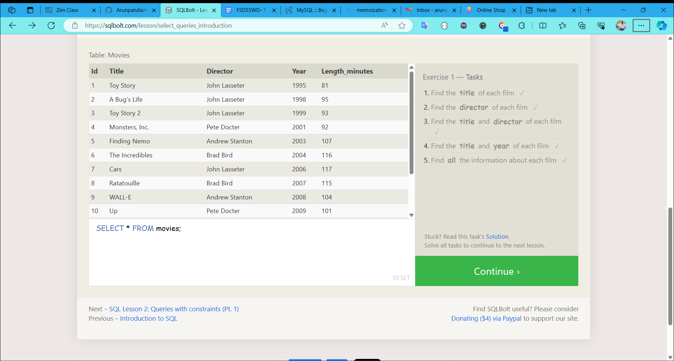

SQL Lesson 2: Queries with constraints (Pt.1)

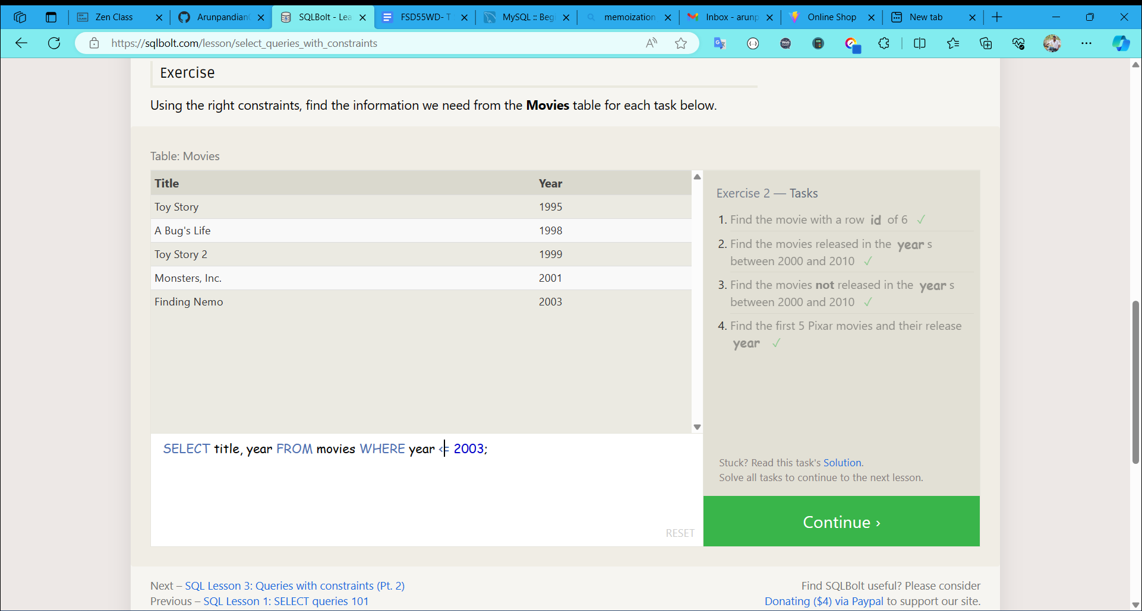

SQL Lesson 3: Queries with constraints (Pt.2)

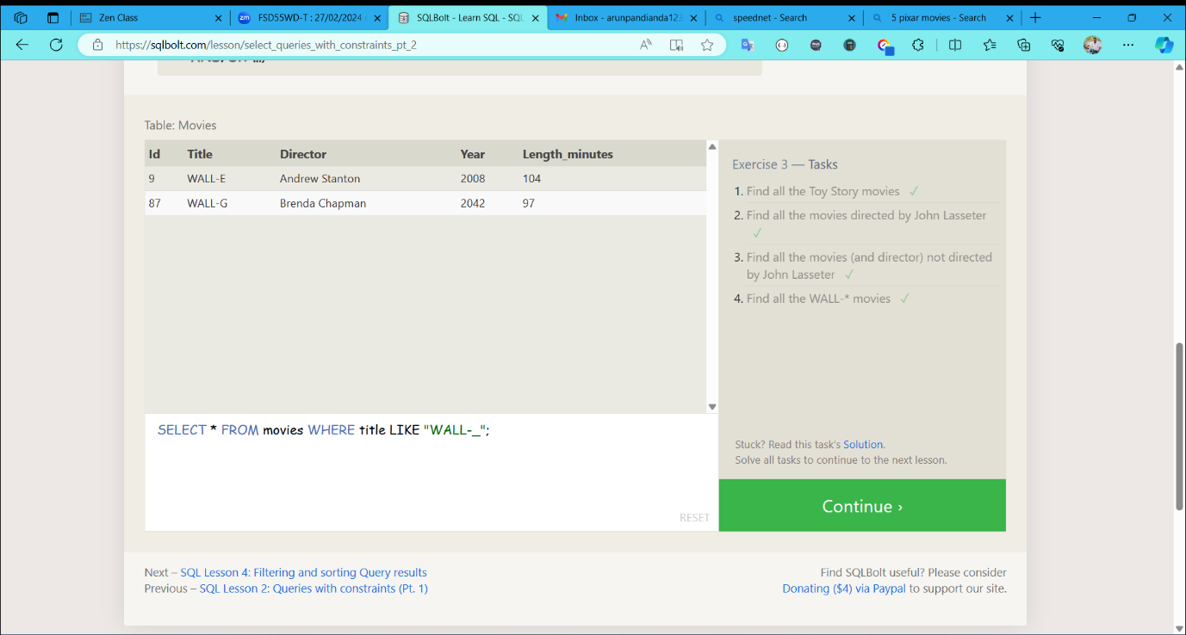

SQL Lesson 4: Filtering and sorting Query results

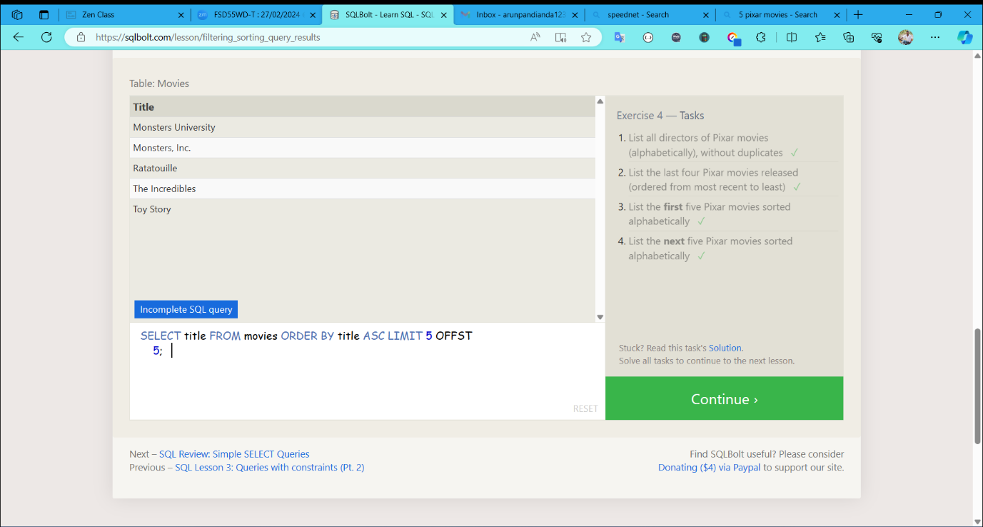

SQL Review: Simple SELECT Queries

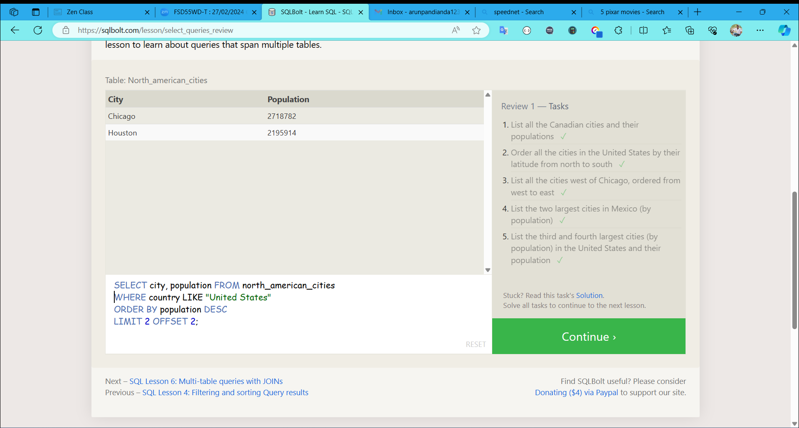

SQL Lesson 6: Multi-table queries with JOINs

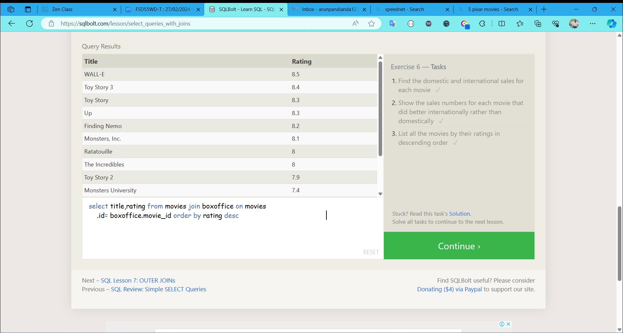

SQL Lesson 7: OUTER JOINs

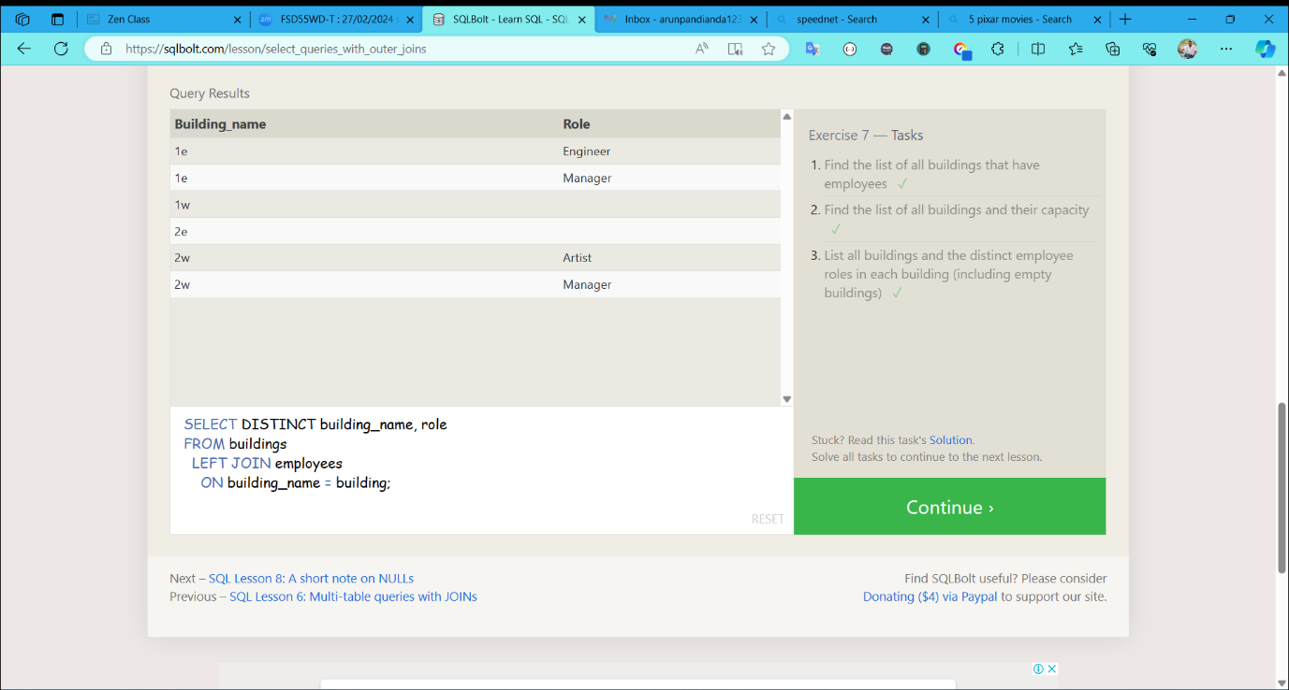

SQL Lesson 8: A Short note on NULLs

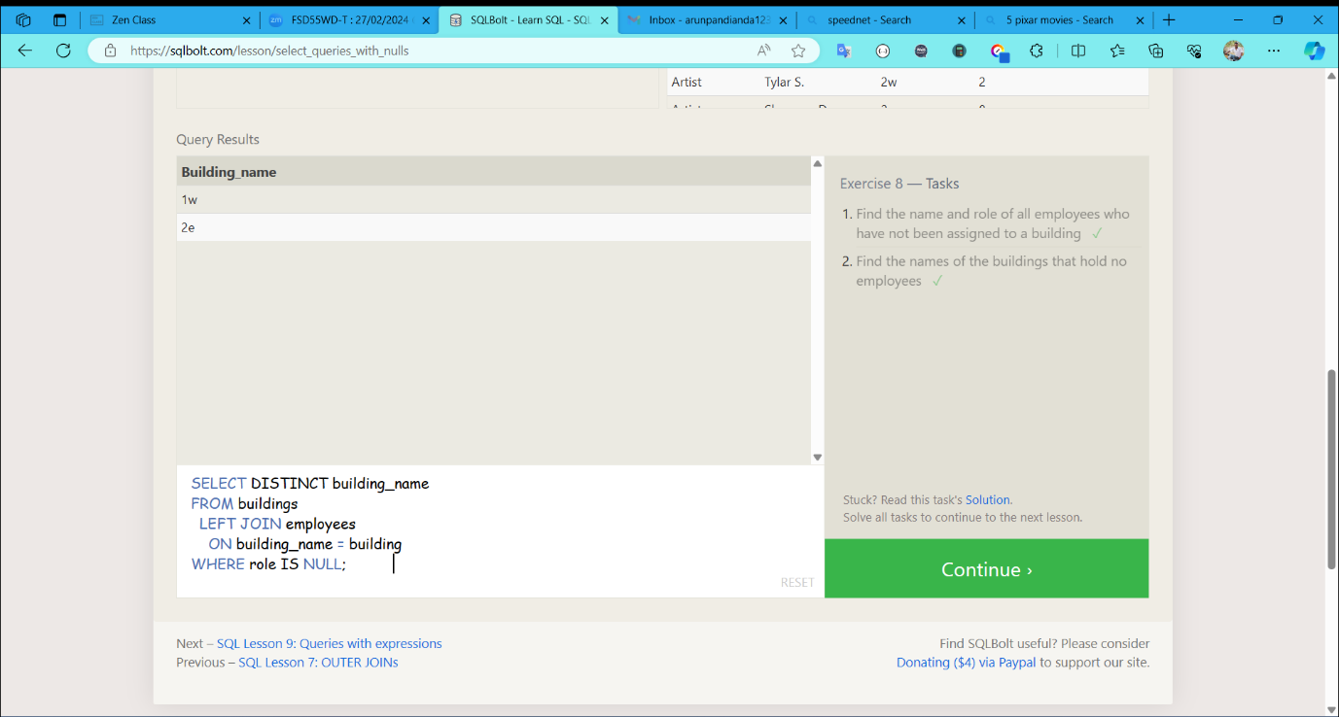

SQL Lesson 9: Queries with expressions

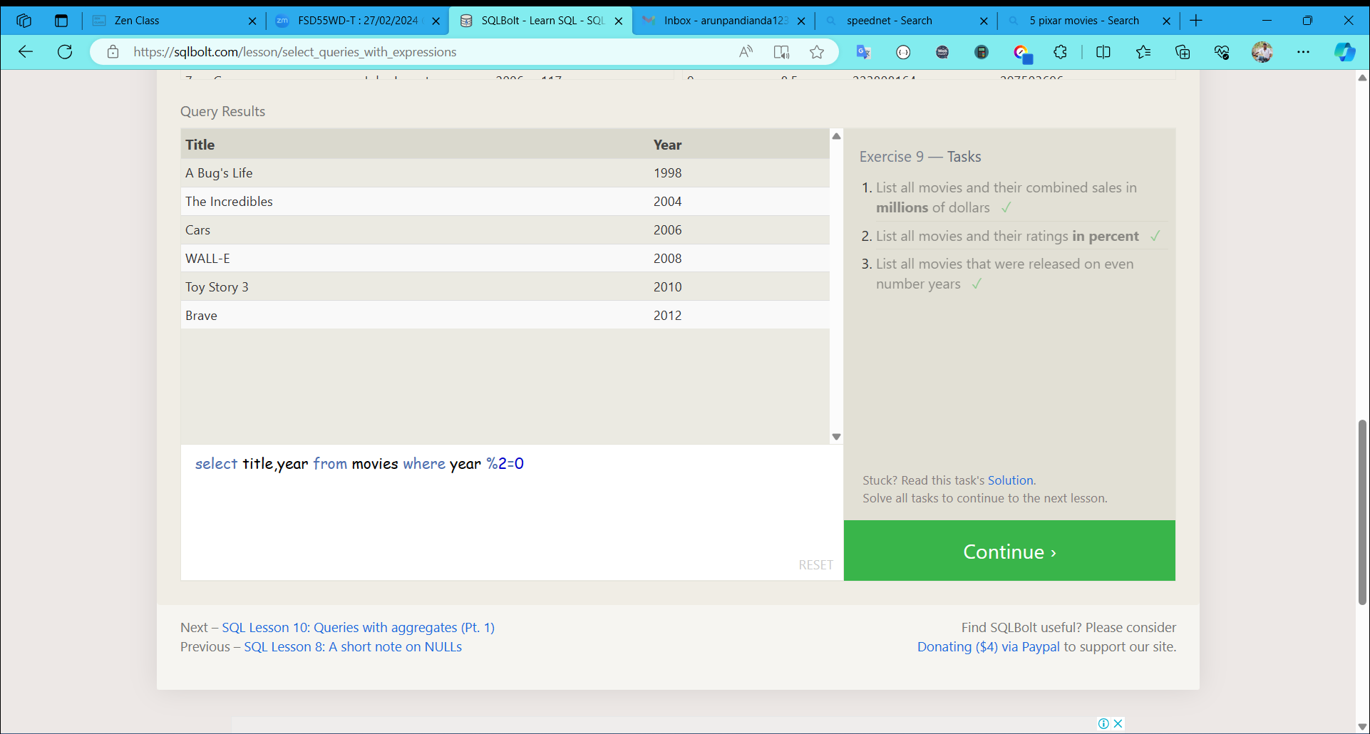

SQL Lesson 10: Queries with aggregates (Pt.1)

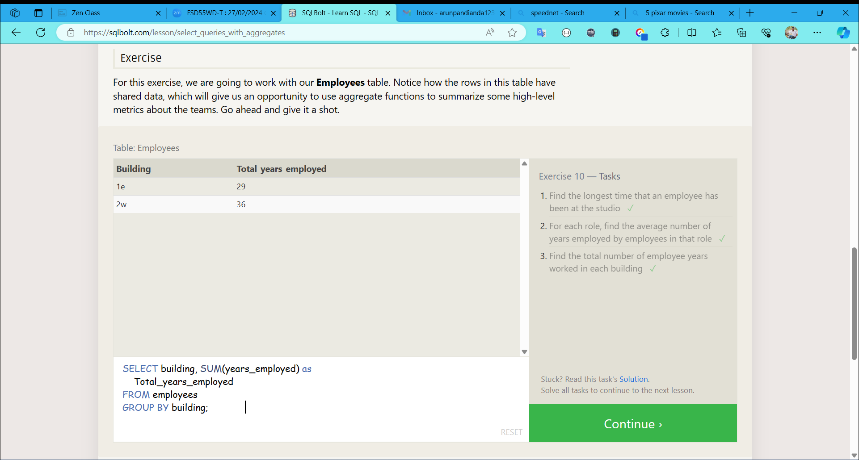

SQL Lesson 11: Queries with aggregates (Pt.2)

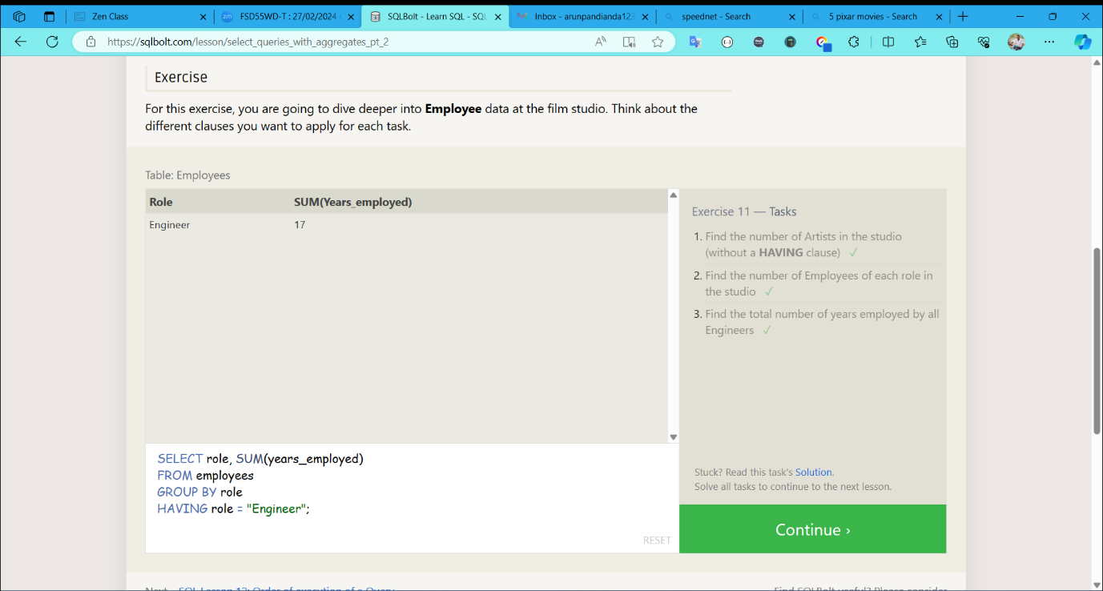

SQL Lesson 12: Order of execution of Query

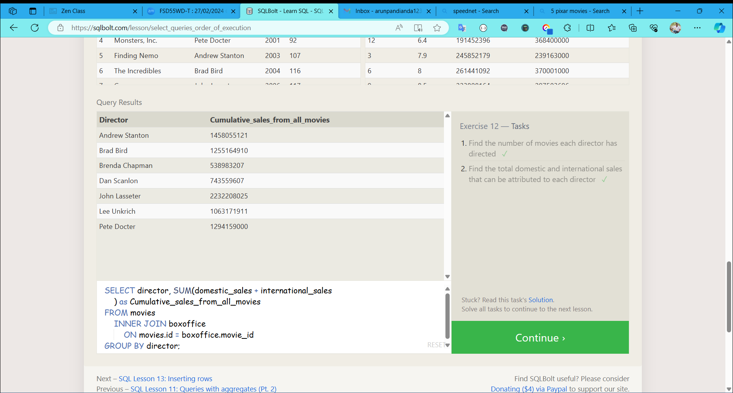

SQL Lesson 13: Inserting rows

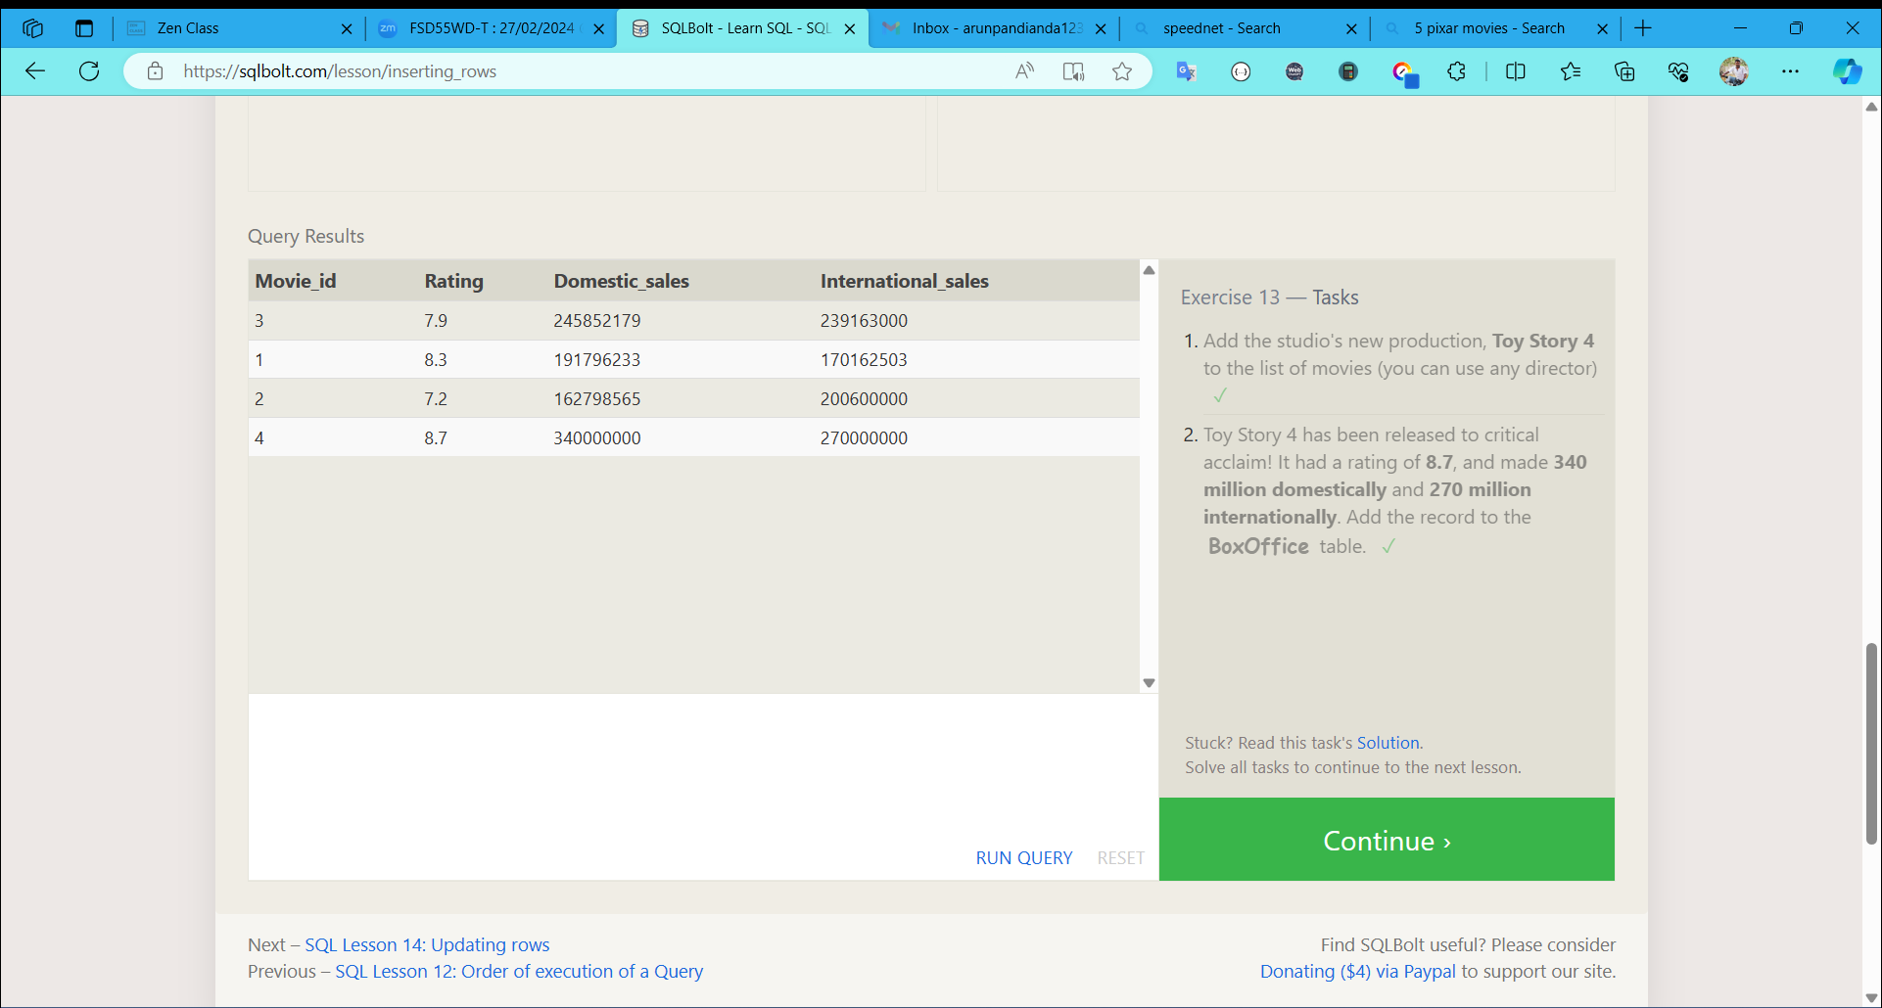

SQL Lesson 14: Updating rows

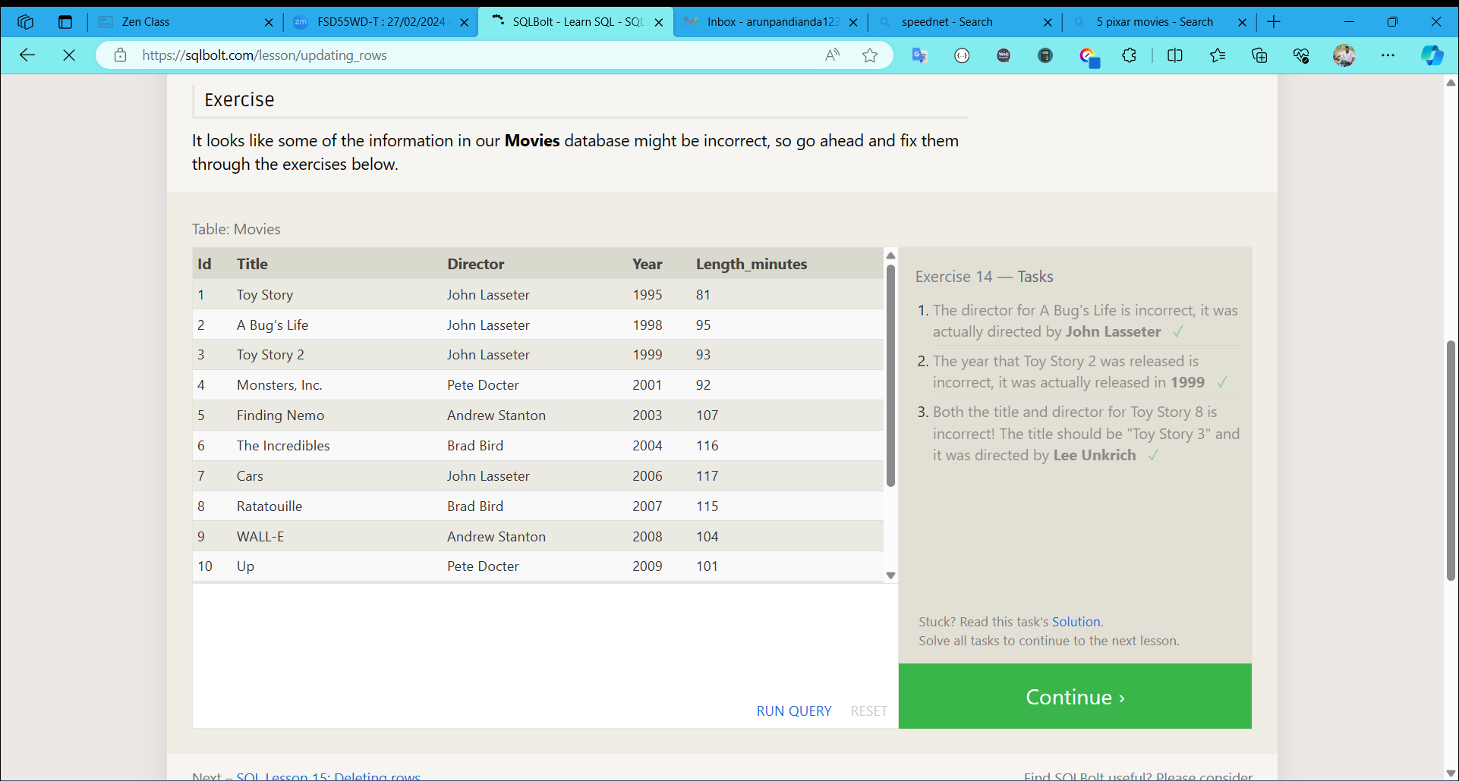

SQL Lesson 15: Deleting rows

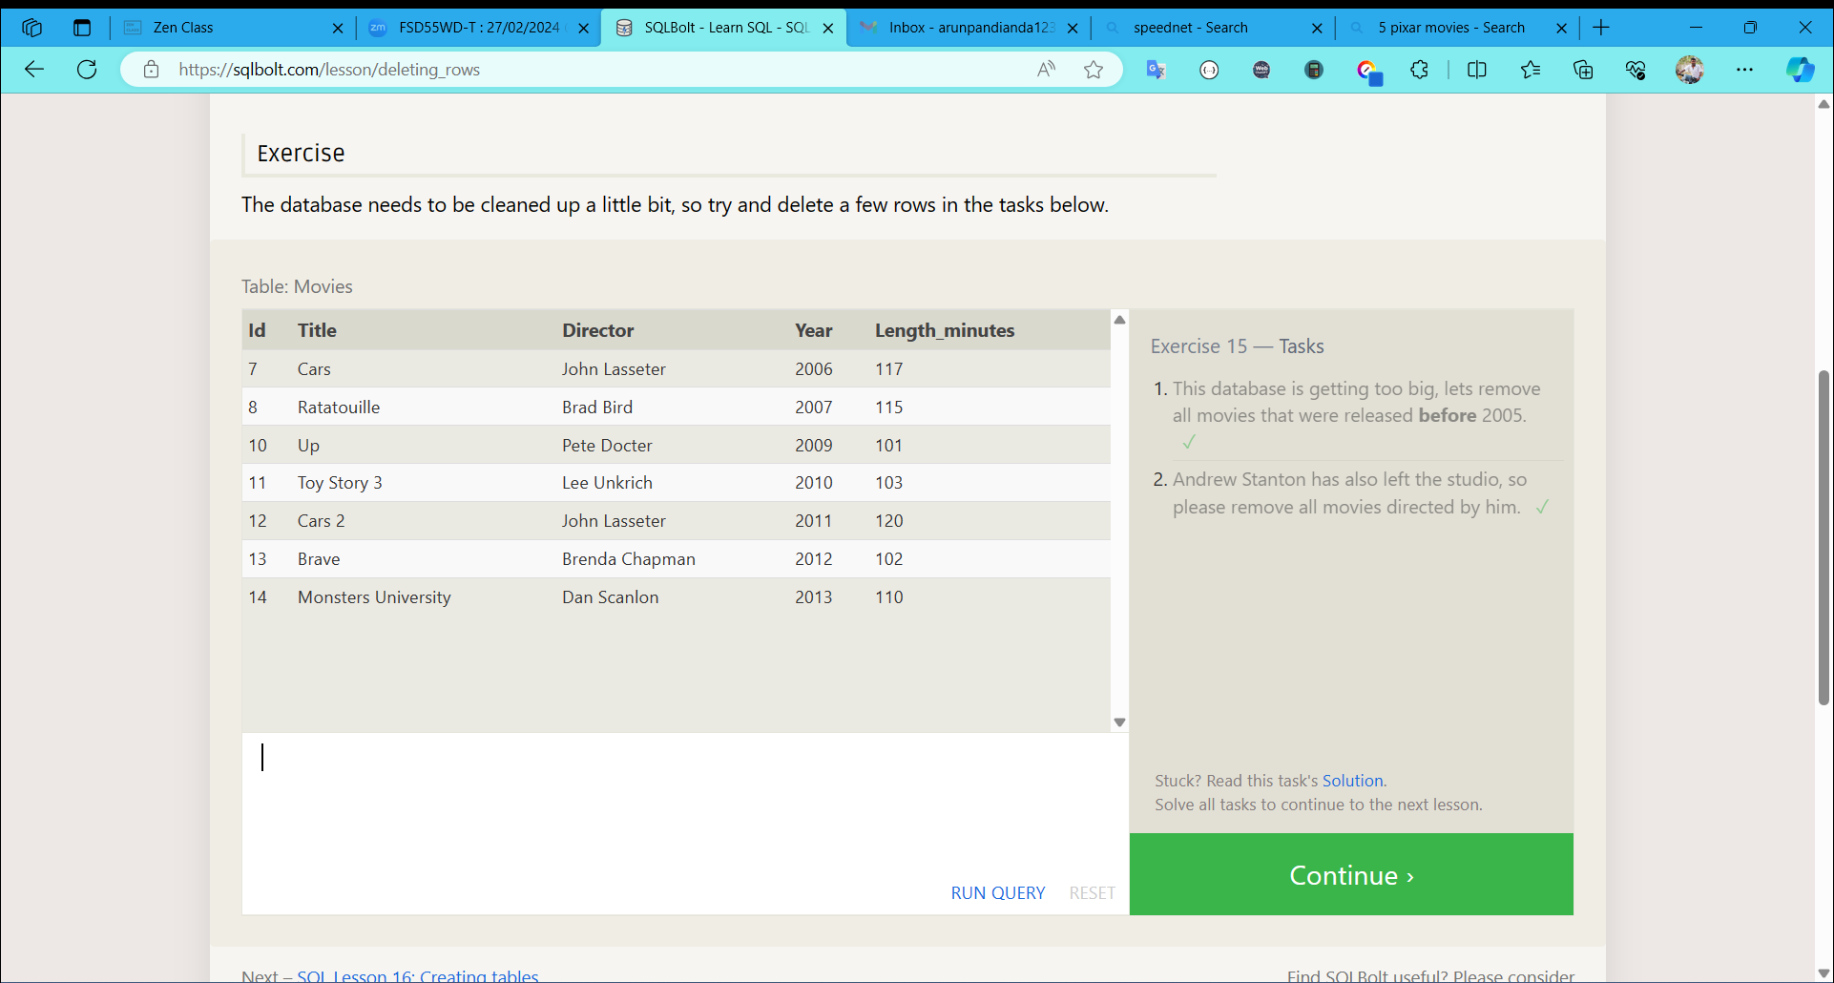

SQL Lesson 16: Creating tables

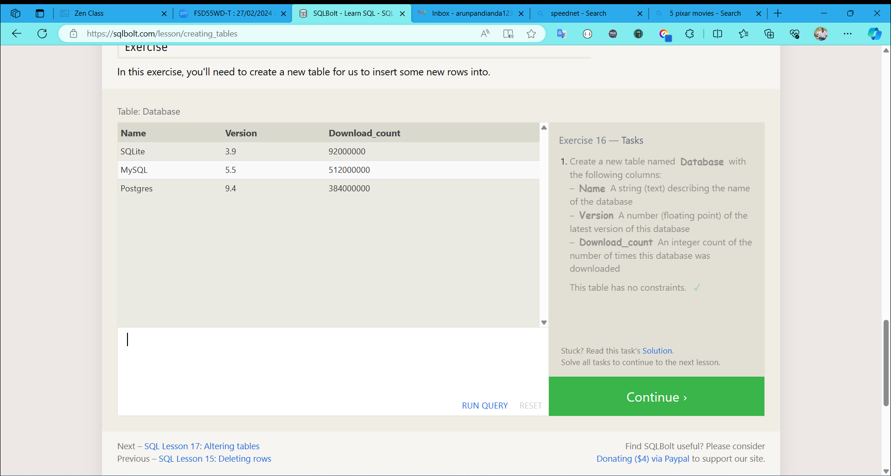

SQL Lesson 17: Altering tables

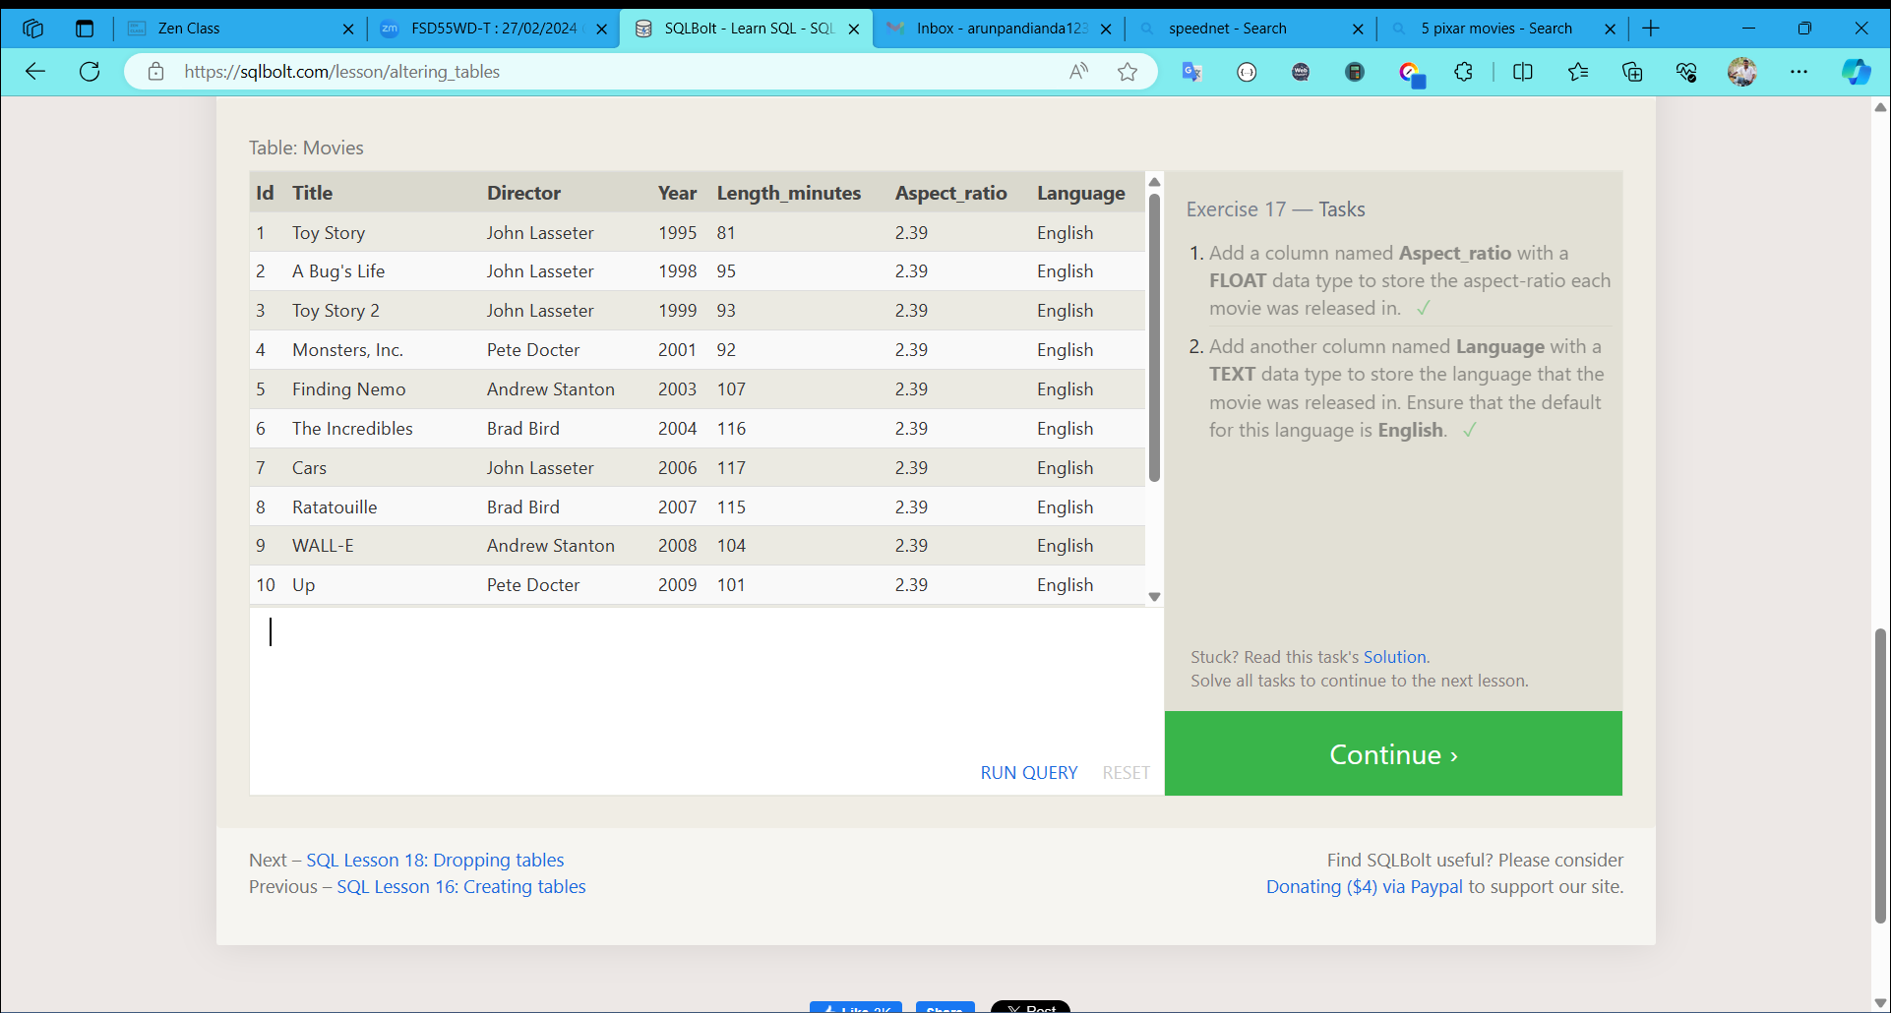

SQL Lesson 18: Dropping tables

